In silico screening of brassinolide-like compounds

○Airi SUGIURA, Seisuke TAKIMOTO, Yuko NAKAMURA, Yoshiaki NAKAGAWA, Hisashi MIYAGAWA (Graduate School of Agriculture, Kyoto University)

1. Introduction
In 1970 a novel plant growth-regulatory substance was isolated from the pollen of Brassica napus L. Its chemical structure was determined as shown in Fig. 1, and named brassinolide (BL) ¹. This compound is characteristic with its steroidal structure, having a ε-lactone (seven-membered ring) substructure. Three years later, a BL like compound containing a six-membered cyclohexanone substructure was isolated from the chestnut gall, which was named castasterone (Cas; Fig. 1). Both BL and Cas showed a unique activity in terms of the regulation of cell elongation/division and the involvement in plant disease resistance. They are now categorized as brassinosteroids (BRs), and to date more than 70 BRs have been identified and/or synthesized. While BRs have been deemed a group of secondary metabolites that have growth regulatory activity toward plants for long time, the discovery and characterization of BL-deficient dwarf mutant established BL as the 6th plant hormone.
Fig. 1 Structures of representative BRs

Steroid hormones are important in animals including insects, and non-steroidal compounds that mimic the steroid hormones are used in pharmaceutical and agricultural markets. Diethylstilbestrol is well known as a non-steroidal mimetic for the female hormone, estradiol. In agrochemical studies, diacylhydrazine (DAH) type compounds that mimic the molting hormone, 20-hydroxyecdysone, are used as insecticides. By contrast, non-steroidal compounds exerting BL like activity have not been discovered to date, although the chemical structure of BL was identified a half century ago.
In 2001 Wang and coworkers published that BRI1 (Brassinosteroid-insensitive receptor kinase 1 ) is the receptor for BL, and later Kinoshita and co-workers reported that BRs bind to the leucine-rich repeat (LRR) domain of the BRI1. Recently, two research groups published three-dimensional (3D) structures of the BRI1-BL complex^{2, 3}. In these crystal structures, the three OH groups of BL (2-OH, 3-OH, 22-OH) do not interact with BRI1 in the ligand-receptor binding. However, it was reported that these OH groups are essential for BL activity by structure-activity study. Meanwhile, a family of SERKs (somatic embryogenesis receptor kinases) has been genetically implicated in mediating early brassinosteroid signaling events as co-receptor candidates. Eventually, the 3D structure of the BRI1-BL-SERK1 complex was solved by X-ray crystal structure analysis⁴, providing a good opportunity for starting in silico screening.
The aim of this study is to find novel non-steroidal BL-like compound using a pharmacophore based in silico screening technique. We used the software package LigandScout developed by Inte:ligand GmbH (Austria), in which the query pharmacophore is generated from the ligand-receptor complex to perform the virtual screening.⁵ The pharmacophore was constructed from the crystal structure of the BRI1-BL-SERK complex (PDB: 4LSX). Screened compounds were purchased and their BL agonist/antagonist activity was evaluated using the rice lamina inclination assay.

2. Method
2.1 In silico screening
The database containing 5,251,975 structures as sdf format was kindly supplied from Namiki Shoji Co., Ltd. (2011.06; Tokyo, Japan). These structures were converted to a multi-conformational compound database as ldb format using OMEGA module of LigandScout (ver. 3.12). The conformation number per molecule was set to 200 in the conformer generation step.
The crystal structure BRI1-BL-SERK1 complex (PDB: 4LSX) used in this study is a homo-dimeric structure with quaternary structure, and contains two BL-binding sites. Therefore, a new pharmacophore model was built by carefully analyzing the crystal structure, as shown in Fig. 2. The spheres corresponding to the excluded volume for the ligand-receptor interaction and hydrophobic interactions were also used for the screening. Excluded volume spheres were derived automatically and placed on alpha carbon atom coordinates of ligand surrounding amino acids. Some features for hydrophobicity and excluded volumes were removed from the default model.
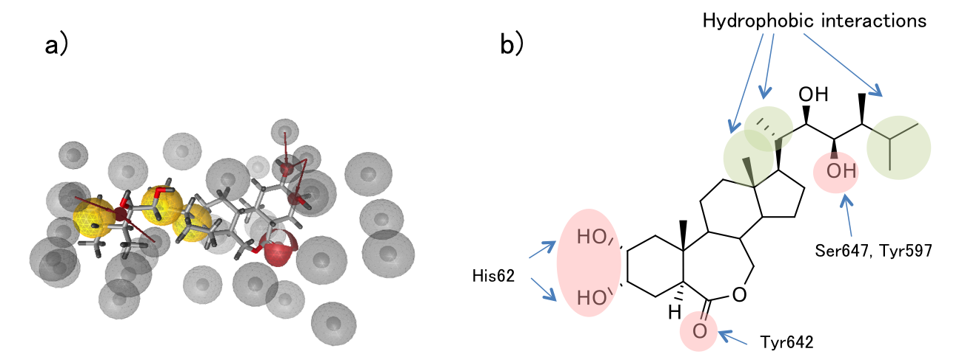
Fig. 2 Pharmacophore model of BL. a) Modified model with exclusion regions. b) Summary of hydrogen bond interactions and hydrophobic regions.

As a result of screening, 22 compounds listed in Fig. 3 were obtained. Among them compounds 1-15 were purchased and submitted to bioassay.

Fig. 3 Structures of hit compounds

2.2 Measurement of agonistic and antagonistic activity
Biological activity was evaluated using the lamina inclination assay. In brief, rice seeds were sterilized with 1% aqueous NaClO solution and germinated in the sterilized water for three days under light at 28 ºC. The sprouted seeds were transplanted into the 1% agar medium and cultured for 5 days under light at 28 ºC.
An EtOH solution of the test compound was applied to the second lamina part of the rice shoot after the application of 0.5 μL of indole-3-acetic acid (50 mM in ethanol). Treatments with 1 μL of ethanol and BL solution (1 × 10⁻⁹ M) were used as negative and positive controls. In the antagonistic activity assay, all shoots were treated with brassinolide (1 nmole/plant). Treatment with test compounds was done just after the application of brassinolide (1 nmole/plant).

3. Results & Discussion
Twenty-two compounds were screened from roughly 5 million structures using LigandScout and 15 compounds were purchased. These 15 compounds were submitted for the lamina inclination assay to measure the BL-agonistic/antagonistic activity. All tested compound did not show BL-like activity, but 3 compounds showed antagonistic activity as shown in Fig. 4.
Fig. 4 Result of antagonistic activity assay

To compare the potency among these three compounds, the dose-response relationship was examined. The dose that inhibits the hormonal effect induced by brassinolide treatment (1 nmole) to 50% (ID₅₀) was evaluated from each response curve. ID₅₀ values of compound 1, 2 and 14 were 3.2, 5.0 and 0.63 nmole, respectively.
The most potent compound was chemically synthesized from para-xylene glycol and 3-ethyl-5-methylisoxazole-4-carboxylic acid. The ID₅₀ value was determined to be 0.26 nmole equivalent to that evaluated for the purchased compound. The features used for in silico screening were mapped onto the structure of compound 14 (Fig. 5)
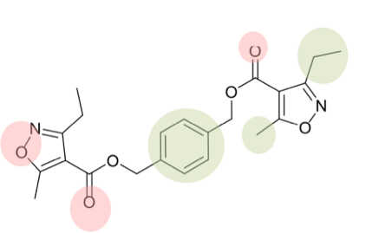
Fig. 5 Mapping of features on the structure 1

4. Conclusion
In silico screening based on a pharmacophore model of BL provided 22 candidates of active compounds from a database of 5,251,975 structures. While none of them showed BL-like activity in the in the lamina inclination assay, 3 compounds were active as antagonist. Structural features of BL were reasonably mapped on the structures of antagonists, and the requirements that determine agonist/antagonist activity of a compound remain to be analyzed further.

5. Reference
1. Grove et al., Nature 201, 216-217 (1979)
2. Hothorn et al., Nature 474, 467-471 (2011)
3. She et al., Nature 474, 472-476 (2011)
4. Santiago et al., Science 341, 889-892 (2013)
5. Wolber and Langer, JCIM 45, 160-169 (2005)

